Workshop on Singular Limit and Related Problems

会议程序册
Program and Abstract

June 3, 2018
Renmin University of China, Beijing, China

Host: School of Information, Renmin University of China

Supported by: Renmin University of China,
National Nature Science Foundation of China

Workshop on Singular Limit and Related Problems
Time | : June 3, 2018
Location | : Room 0305, Ming De Main Building, Renmin University of China (near the west gate of Renmin University )  人民大学明德主楼0305 (近人民大学西门)

Invited Speakers:

Feimin Huang | Chinese Academy of Sciences
Qiangchang Ju | Institute of Applied Physics and Computational Mathematics
Fucai Li | Nanjing University
Hailiang Li | Capital Normal University
Steve Schochet | Tel Aviv University
Shu Wang | Beijing University of Technology
Xin Xu | Institute of Applied Physics and Computational Mathematics

Organizing Committee:

Song Jiang | Institute of Applied Physics and Computational Mathematics
Qiangchang Ju | Institute of Applied Physics and Computational Mathematics
Yaobin Ou | Renmin University of China

Contact Information:

Yaobin Ou: ou@ruc.edu.cn, 010-82504654, 13910462097
Kunquan Li: kunquanli@ruc.edu.cn, 18811762836
Lu Yang: yanglu96@ruc.edu.cn，18813123199

Schedule:Workshop on Singular Limit and Related Problems
Sunday morning (June 3)
Room 0305, Ming De Main Building, Renmin University of China ( near the west gate of Renmin University of China), (明德主楼0305教室，人民大学西门附近)
8:30-8:50 | Registration
8:50-9:00 | Opening ceremony
Session I | Chair:
9:00-9:45 | Steve Schochet, Tel Aviv University  Three-Scale Singular Limits of Evolutionary PDEs
9:45-10:15 | Tea Break and photos
Session II | Chair:
10:15-11:00 | Feimin Huang , Chinese Academy of Sciences  Boltzmann equation with initial large amplitude data
11:00-11:45 | Fucai Li, Nanjing University  Incompressible limit of the degenerate quantum compressible Navier-Stokes equations
12:00-14:00 | Lunch Break (Huixian Restaurant 汇贤府, 3rd floor, Central Canteen)
Sunday afternoon (June 3)
Session III | Chair:
14:00-14:45 | Shu Wang , Beijing University of Technology  Quasineutral Limit of Drift-diffusion Models for Semiconductors and the Related Models
14:45-15:30 | Qiangchang Ju,Institute of Applied Physics and Computational Mathematics  Small Alfven number limit of the compressible magnetohydrodynamic equations
15:30-16:00 | Tea Break
Session IV | Chair:
16:00-16:45 | Hailiang Li ,Capital Normal University  Behaviors of Navier-Stokes(Euler)-Fokker-Planck equations
16:45-17:30 | Xin Xu , Institute of Applied Physics and Computational Mathematics  Stability of boundary layers for Navier-Stokes Poisson system in half-space
18:00-20:00 | Banquet (Huixian Restaurant, 3rd floor, Central Canteen)

Workshop on Singular Limit and Related Problems
Renmin University of China, Beijing, China
June 3, 2018

Title and Abstract

Three-Scale Singular Limits of Evolutionary PDEs
Steve Schochet
Tel Aviv University
E-mail address: Schochet@post.tau.ac.il

Abstract: Singular limits of a class of evolutionary systems of partial differential equations having two small parameters and hence three time scales are considered. Under appropriate conditions solutions are shown to exist and remain uniformly bounded for a fixed time as the two parameters tend to zero at different rates. A simple example shows the necessity of those conditions in order for uniform bounds to hold. Under further conditions the solutions of the original system tend to solutions of a limit equation as the parameters tend to zero. Joint work with Bin Cheng and Qiangchang Ju.

Boltzmann equation with initial large amplitude data
Feimin Huang (黄飞敏)
Chinese Academy of Sciences
E-mail address: fhuang@amt.ac.cn

Incompressible limit of the degenerate quantum compressible Navier-Stokes equations
Fucai Li (栗付才)
Nanjing University
E-mail address: fli@nju.edu.cn

Abstract: In this talk we shall discuss the incompressible limit to the degenerate quantum compressible Navier-Stokes equations in a periodic domain and the whole space with general initial data.

Behaviors of Navier-Stokes(Euler)-Fokker-Planck equations
Hailiang Li (李海梁)
Capital Normal University
E-mail address: hailiang_li@mail.cnu.edu.cn

Abstract: We consider the behaviors of global solutions to the initial value problems for the multi-dimensional compressible Navier-Stokes(Euler)-Fokker-Planck equations. It is shown that due the micro-macro coupling effects, the sound wave type propagation of this NSFP or EFP system for two-phase fluids is observed with the wave speed determined by the two-phase fluids. This phenomena can no be obsered for the pure Fokker-Planck equation.

Small Alfven number limit of the compressible magnetohydrodynamic equations
Qiangchang Ju (琚强昌)
Institute of Applied Physics and Computational Mathematics
E-mail address: ju_qiangchang@iapcm.ac.cn

Abstract：Even though much progress has been made in proving the singular limits of quasi-linear hyperbolic system with small parameters since the classical work by Klainerman and Majda , there are no rigorous proofs for small Alfv\'{e}n number limit of the compressible magnetohydrodynamic flows except the work by Browning and Kreiss under unnatural initial conditions. In this talk, some recent studies on small Alfven number limit of the compressible magnetohydrodynamic equations will be presented under appropriate conditions.

Quasineutral Limit of Drift-diffusion Models for Semiconductors and the Related Models
Shu Wang (王术)
Beijing University of Technology
E-mail address: wangshu@bjut.edu.cn

Abstract: In this talk I will discuss quasineutral limit of Drift-diffusion models for semiconductors and the related models. Quasineutrality assumption is one basic physical assumption,raised by W. Van Roosbroeck (Bell System Tech. J., 1950). I will talk some mathematical theory of quasineutrality for semiconductor and plasma. Some rigorous convergence results on structure stability are reviewed and some new results obtained recently will be given.

Stability of boundary layers for Navier-Stokes Poisson system in half-space
Xin Xu (徐鑫)
Institute of Applied Physics and Computational Mathematics
E-mail address: xuxinaboy@126.com

Abstract: We are concerned with the quasi-neutral and zero-viscosity limits of Navier-Stokes-Poisson equations in the half-space. By means of asymptotic analysis with multiple scales,we construct an approximate solution of the Navier-Stokes-Poisson equations, and establish the stability of the boundary layer approximations by conormal energy estimate.

Local Information about lodging, lecture hall :
当地信息（住宿、会议地点）：
- Lodging for non-local speakers: Yanshan Hotel, #38 Zhongguanchun Street, Haidian District, Opposite the east gate of Renmin University, next to the Contemporary Mall.
住宿地点: 北京市海淀区中关村大街甲 38 号 燕山大酒店（人民大学东门对面，当代商城旁边）

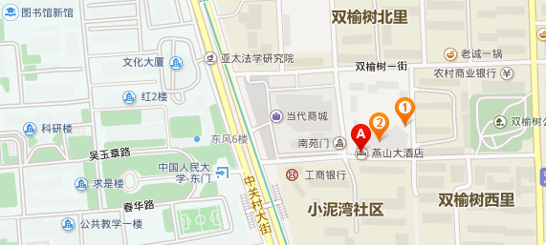

- Location of lecture hall: Room 0305, Ming De Main Building, Renmin University of China （Walking into the west gate of renmin university, the first building on the left of the road is the Mingde building）.
会议地点：中国人民大学明德主楼0305教室 （走入人民大学西门，道路左边的第一栋楼就是明德楼）。

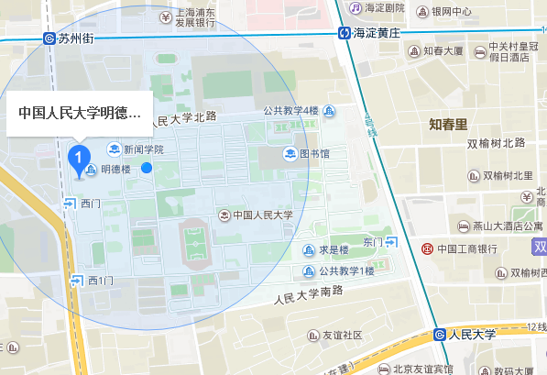

Details are as follows: （详细信息如下:）

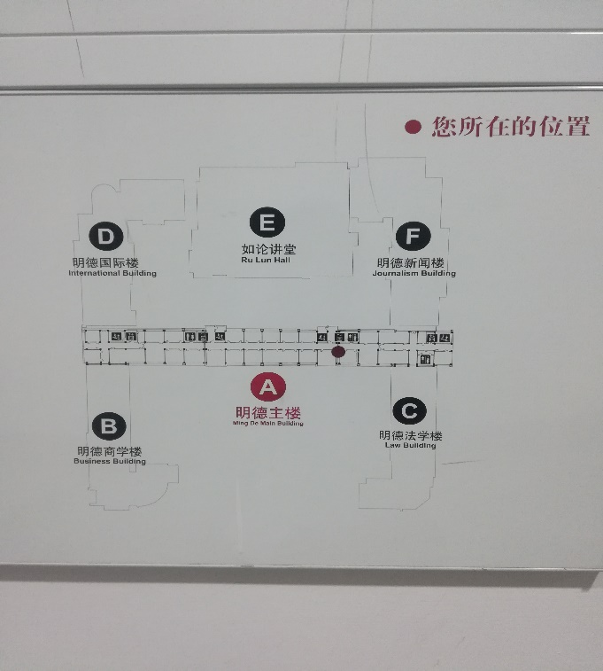 | 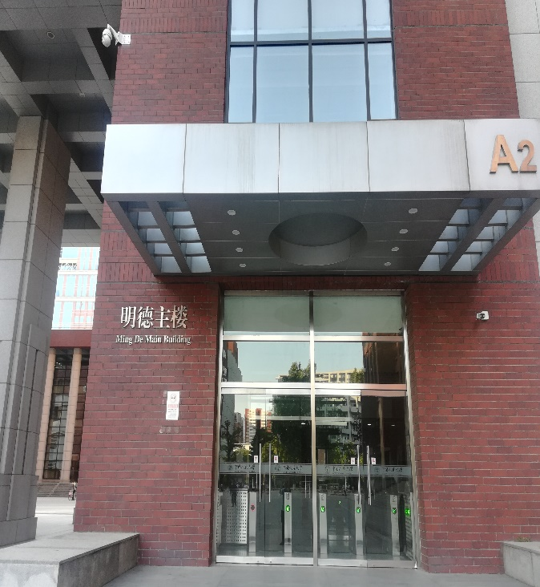

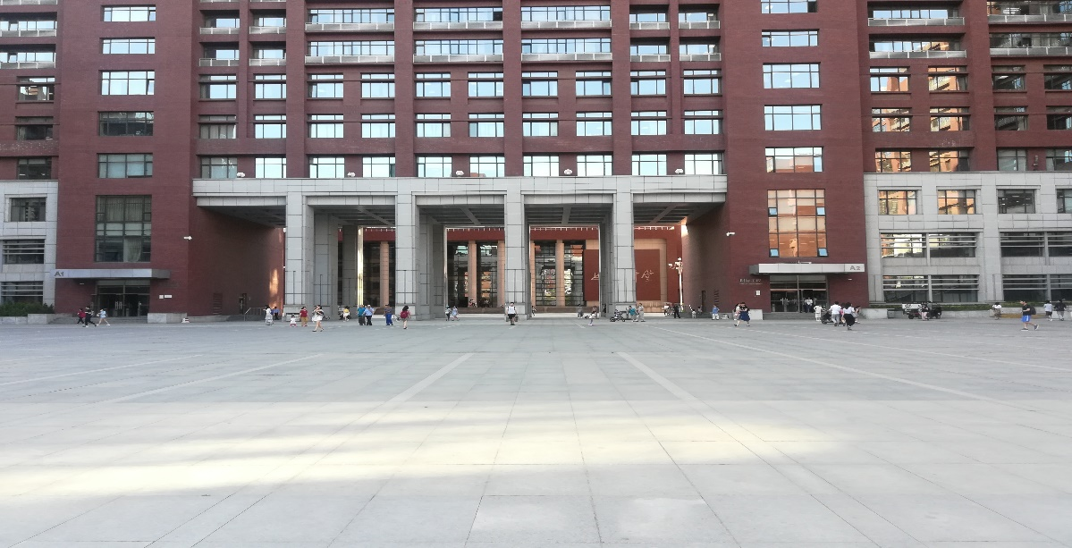
Enter into Entrance A2 (on the right-hand side of the above picture), take the stairs to the third floor, room 0305, or after entering the hall from A2, then turn right to the end of the corridor, there is an elevator, take the elevator reaches 3rd floor, next turn right and walk to room 0305.
从A2(上图右侧入口)进入，走楼梯到达3楼，0305教室，
或者从A2进入大厅后，右转到楼道尽头，有一个电梯的地方，乘电梯到达3层，右转步行至0305教室。

人大校内Wi-Fi使用办法
(To use Wi-Fi on RUC campus, please ask the organizers for help)
Step 1: 开启Wi-Fi接收，人大Wi-Fi名称前缀是RUC_，打开浏览器，在地址栏中输入go.ruc.edu.cn并点击回车
Step 2：点击 “手机注册”（左上图是电脑登录页面，右上图是手机登录页面）
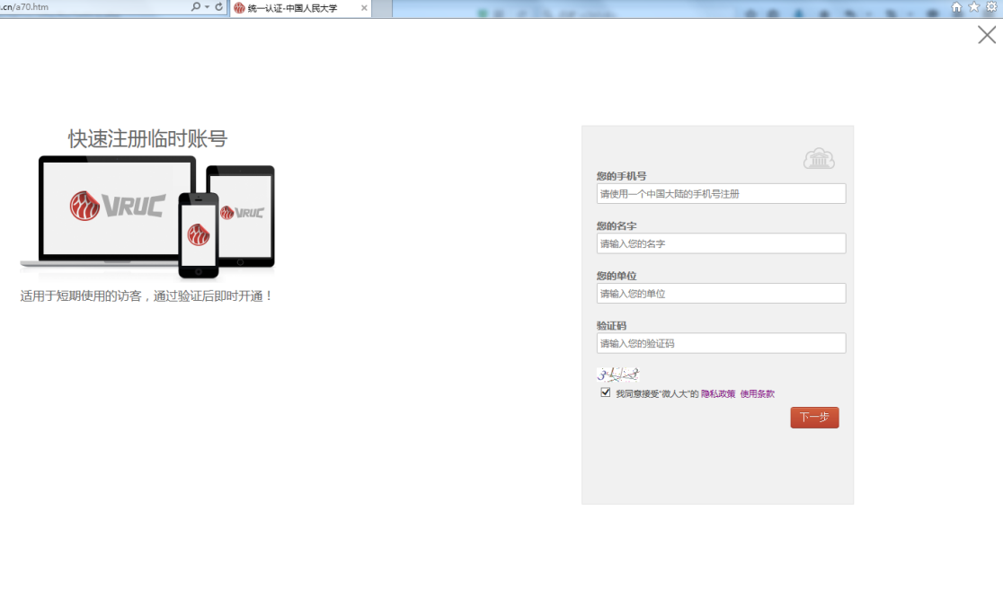
Step 3：填写手机号，姓名，单位，验证码后点击“下一步”，手机会收到一条4位验证码的短信，点击右上角的“×”回到Step 1的页面，在“身份认证”第一栏输入手机号，第二栏输入刚收到的4位验证码，点击“登录”即连入Wi-Fi。

